Name : Saurabh Sanjay Jadhav

Topic : Docker Volume & Create customized image.

Assignment no : 8

1. Install docker in ubuntu OS.

curl -fsSL https://get.docker.com -o install-docker.sh

sh install-docker.sh

1. Create docker volume
2. Create directory on our instance “/data”
3. Docker run –name cont1 -v /data -it ubuntu
4. Check that “/data” is mounted in docker.

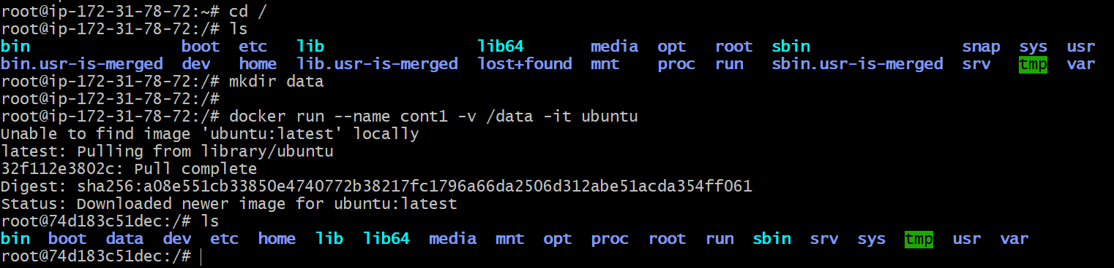

1. Create files & directories in container inside /data.

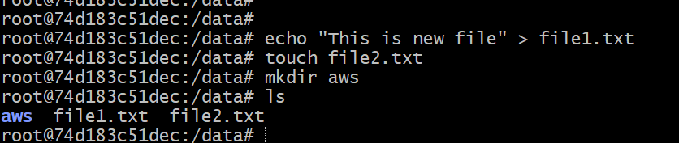

1. Check the mount location for cont1 container.

Docker inspect cont1

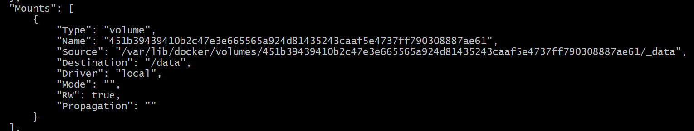

Go to the source location and check the files & dir created in container.



1. Volume sharing by cont2.
2. Create new container with volume sharing from cont1.

Docker run –name cont2 –volumes-from cont1 -it ubuntu

1. Check whether the files of cont1 are visible.
2. Create new files from cont2.

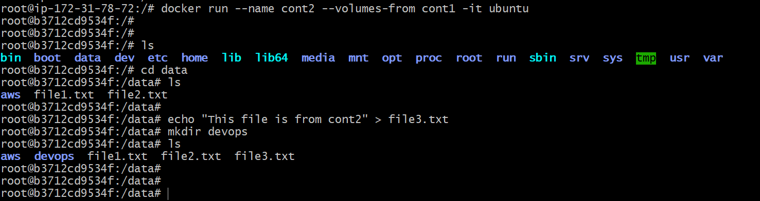

1. Similarly volume sharing by cont3.

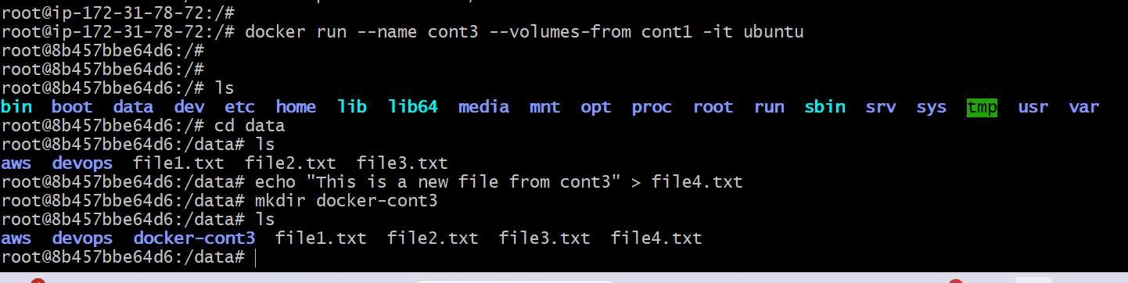

1. Finally we are able to view the all the files & directories created by all container using source location.



1. Create customized image from docker.
2. Installed the vim package on cont1
3. Create image from container

Docker commit cont1 ubuntu-vim

1. Check the images in local docker.

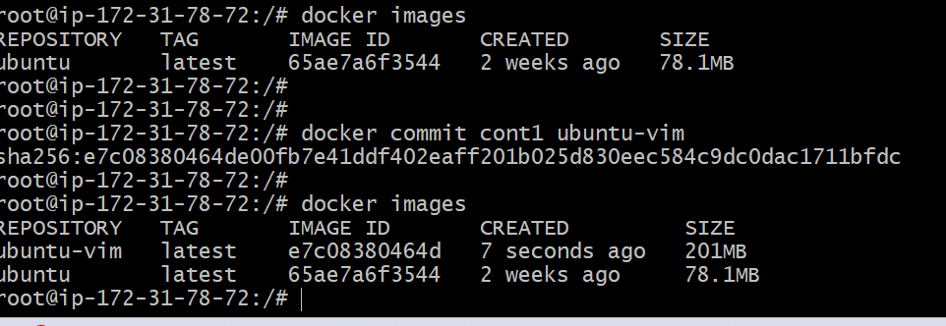

1. Docker attach cont2 -------> to get into running container.